West Cromwell Road – Landscaping Specifications
Proposal for landscaping works along West Cromwell Road. including general maintenance of assets, replacement planting and complete a general tidy up of the green infrastructure.
Proposals
Gabions
The gabion wall and the planters within it do not appear to be visible within Surfaceplaybook.
A proposal to cover the Gabions with climbing plants was completed in early 2025. The climbers are slowly establishing, however currently they have become a little untidy and the following works are recommended:
- Remove all weeds from gabions.
- Climbing plants to be trained over the top of the gabions, with Twining Stems/ Bines to be tied down to top sections using biodegradable plant ties to encourage growth over the gabions.
- Remaining growth to be trimmed to tidy up and promote growth along the gabions.
- Trim and train gabions to go around planted areas.
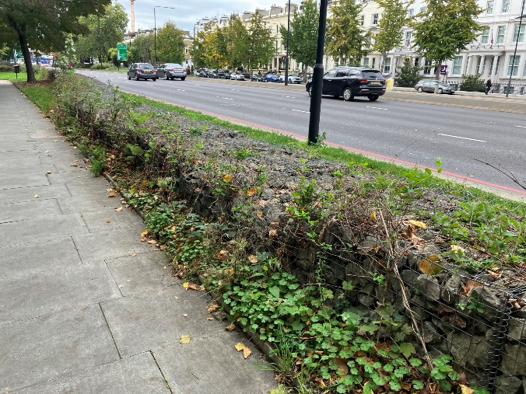 | 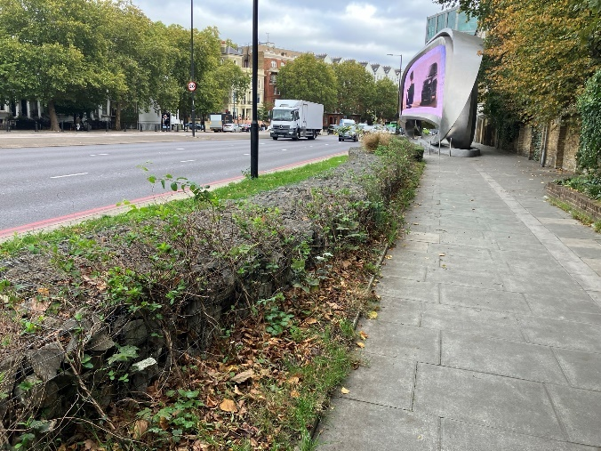
Photograph 1: Showing weeds around gabions. | Photograph 2: Showing climbers and weeds on gabions.
Gabion planters
Within the Gabions there are approximately 8 panted areas, over the years these have been panted with several varieties of species and have had varying decorative stones added. At present there is no conformity within them. It is recommended that the following works are undertaken:
- Gabions and planted areas added to Maximo and added to ongoing maintaince regimes.
- The gabion beds are tidied up with a complete manual weed removal and any dead removal removed. Trim climbers so they cover gabions only.
- All plants to be removed within the planter areas. except for any living ornamental grasses that are located centrally in the beds.
- The existing mineral mulch (decorative stones) and the weed membrane removed.
- Any dead leaves or material are removed.
- The top layer of soil is broken up to at least a depth of 100mm and additional topsoil added as required, the topsoil should be of a General-Purpose Grade conforming to BS3882.
- New plants installed as per the species and locations noted below. It is essential that the planting is to a high density to provide a dense cover to limit future weed growth.
- Install an organic wood mulch underneath the plants.
- Ensure they are watered when planted.
- The planted areas will be subject to a 36-maintenance programme as per the HMPF Contract.

Species for Gabion planter areas.

Species | Common name | EV/ DEC | Feature | Planting  Size | Planting density and locations
Central Grasses
Miscanthus Starlight |  | DEC | Arrow silvered green foliage topped by masses of pinkish silvery beige flowers | 5L | 3 to 5 per planter depending on planter size, with species planted centrally.
Groundcover
Erigeron  karvinskianus  'Lavender Lady' | Mexican Fleabane | Per | Long flowering period from April to November | 2L pot, minimum 10cm’s in height | 5- 7 per sq m planted around the central grasses
Bulb planting (optional)
Allium Purple Sensation |  |  | Summer colour |  | 20 bulbs per m2

Photograph 3: Showing gabions with some ornamental grass remaining. | Photograph 4: Showing removed sections of stones.

Yew Hedge which runs along the rear of the westbound pavement.
The yew hedgerow has established well and now requires some general management. At present the hedgerow asset is not currently recorded on Maximo. To ensure continued management it is recommend it is added to allow for future management.
The current required works consist of the following:
- Remove and dead leaves and rubbish at base of hedge and over plants.
- Remove and climbing plans such as ivy starting to grow through the hedge.
- Trim front, end and top edges to form a tightly clipped hedge.
- Infill any gaps which have occurred either due to removals or death. The plants are to be a minimum size of 60cm in height and be in 3 litre pots unless supplied as root balled. The ground around them will be cleared and plants will be planted at 40cm spacing, with mulch laid around the base to cover 1m²and be between 75mm and 100mm think. This includes the area to the rear of 52/54 Longridge Road and to the side of 17 Nervern Road (not in front of low-level windows).
- Additional planting of Liriope muscari (big blue lilyturf) should be installed in front of hedge where gaps occur.
- The planted areas will be subject to a 36-maintenance programme as per the HMPF Contract.

Photograph 5: Showing gap in yew hedge to side of 17 Nervern Road. | Photograph 6: Showing gap in yew hedge at rear of of 52/54 Longridge Road.

It is proposed that the planters have a central, multi-stemmed large shrub/ small tree to provide year-round interest. The planting needs to be drought tolerant but in order to maintain as much moisture in the soil as possible it is proposed that the shrubs underplanted with equally drought tolerant groundcover.

Planting of empty raised bed asset 200100007782
The raised planter is currently bear with no plantes present. It is recommended the following works are completed:

- The beds are tidied up with a complete manual weed removal.
- Any dead leaves or material are removed.
- The top layer of soil is broken up to at least a depth of 100mm and additional topsoil added as required, the topsoil should be of a General-Purpose Grade conforming to BS3882.
- New plants installed as per the species and locations noted below. It is essential that the planting is to a high density to provide a dense cover to limit future weed growth.
- Install an organic wood mulch underneath the plants.
- Ensure they are watered when planted.
- The planted areas will be subject to a 36-maintenance programme as per the HMPF Contract.

Species for raised bed

Species | Common name | EV/ DEC | Feature | Planting Size | Planting density and locations
Groundcover
Erigeron  karvinskianus  'Lavender Lady' | Mexican Fleabane | Per | Long flowering period from April to November | 9 cm pot | 5-7 per sq m throughout planter for full coverage
Bulb planting (optional)
Allium Purple Sensation |  |  | Summer colour |  | 20 bulbs per m2

The above species mix can also be utilised for any raised wooden box planters on Warwick Road which are to be retained for the short term.
Works to ground level landscaping area asset 200100007767
The ground level planting next to the raised beds has become slightly trampled and the ground cover cotoneasters are struggling. To refresh this area the following works are recommended:
- The existing cotoneaster are removed, and the exposed areas are tidied up with a complete manual weed and rubbish removal.
- Any dead leaves or material are removed.
- The top layer of soil is broken up to at least a depth of 100mm.
- New plants installed as per the species and locations noted below. It is essential that the planting is to a high density to provide a dense cover to limit future weed growth.
- Ensure they are watered when planted.
- The planted areas will be subject to a 36-maintenance programme as per the HMPF Contract.

Species
Suggested species mix below.
Species | Common name | EV/ DEC | Feature | Planting Size | Planting density
Shrubs
Mahonia media Winter Sun |  | Ev |  | Minimum 5L pot | 7 planted around edges, with a minimum gap of 20cm form pot edge to kerb line.

Photograph 7: Showing empty raised bed. | Photograph 8: Showing trampled areas of ground level bed.

Tree works to asset 7876413
During our site visit it was noted that the young Sweet Gum was in a good condition, but the crown has become low over the footway. The following work is recommended:

- Raise low crown to 2.5m all round.

