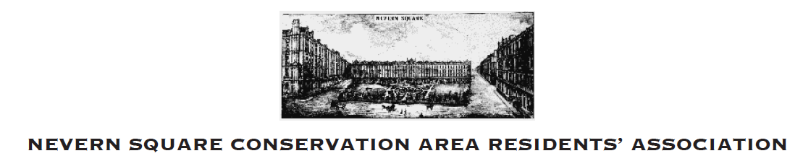

Financial Statement to 30 September, 2023

31 December 2022 £3613.78

Income
Subscriptions 27.00
Deposit from RBKC 381.29
Deposit K Moffatt 50.00

Expenditure
Kensington Society Membership (15.00)
Earls Court Society (10.00)
Coronation Garden Party (209.22)
Greening Program- film crew donation (220.15)

Closing Balance
30 September 2023 £3617.70

